COURSE COSTS AND BOOKING
We are now taking bookings for the September 26 – July 27 year: places are limited to 12 students, it is open to all with a keen interest in herbal medicine, and hopefully have some access to wild herbs in your area. This course could also be for those who live distantly but have access to a temperate climate like N. Europe, the Eastern states of the US and Canada.
The cost of the whole course is £645 – this includes:
- 10 modules of 2 ½ hours of interactive live webinar tuition on Zoom
- Four practical days of herb walks, making remedies and getting to know the group on Sundays over the year
- Plant Spirit Medicine tuition and experience - for a plant study at Totnes or in your locality
- Option of course assignments with marking and feedback
- Encouragement to connect with the other students
The PRACTICAL DAYS will take place on weekends in October, December, late March and late May, and the will be a plant study in your own locality in early June. We recommend you come to them to help you identify the herbs and develop hands-on skills making the remedies, meet us and the other herbal students.
If you are from outside of the U.K.; or are not able to travel, we can give you additional tuition to enable you to complete the practical day on your own. (Additional tuition is £40 for each extra session , which includes support and feedback for your work).
Although some people will do this course for pure enjoyment, there are optional coursework assignments that attendees can do, with feedback given. In acknowledgement of this, the end of course completion certificate will state either attendance only, or completed with commendation, as some students may wish to use this course as a foundation to access further study such as the Higher Diploma course in Herbal Medicine.
If you have any learning needs that we can support you with please let us know.
Concessions are available for low waged: £595.
Other payment options are £145 non -refundable deposit and 4 further payments of £125 from October to January.
To book your place fill in the form below and return it to sarajanehills@gmail.com
We are accredited with the Complementary Medicines Association.


APPLICATION FORM “HERBAL WISDOM” 2026- 27 year.  Personal information will be kept confidential |  | 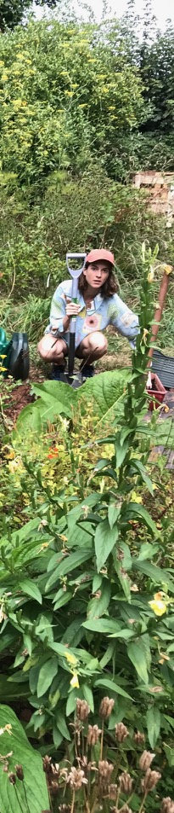
Name

Address

Email

Telephone number with dialling codes if out of the UK.
Name and telephone number of who to contact in case of emergency
Date of Birth
Is there anything about your attendance on the course that you need to tell us about?
Do you have access to locally growing wild plants? If so tell us a little of where you would go to find wild plants or send a photo.
Payment details – Please let us know when you have paid. | Sara-Jane Hills: BACS sort code 608371 account number 63693476 (Starling)  PLEASE EMAIL THIS FORM TO sarajanehills@gmail.com

