Herbal Wisdom – a one year foundation course in Herbal Medicine

This earth-based course is centred around our native plants.
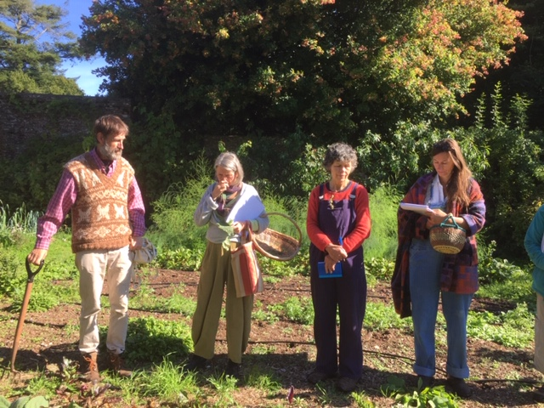
In the walled garden – photo: Sara Hills
With live online tuition and four practical workshop days in
beautiful Devon countryside, you can gradually develop a
competent proficiency within the course framework to
recognise, gather and make your own herbal remedies for
treating yourself, family and community.
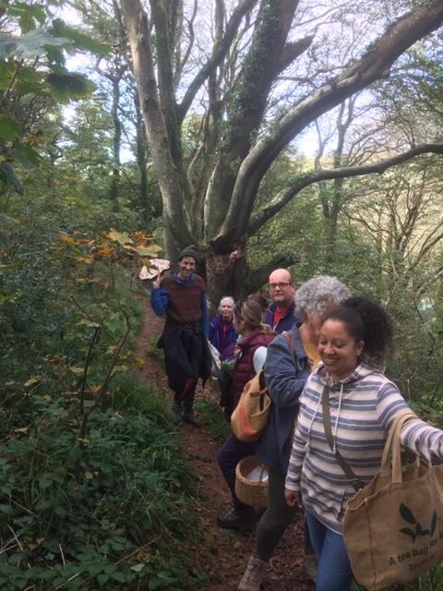
Top of the woods – Photo: Sara Hills
This course is open to anyone with an interest in
the natural world, anyone prepared to be
immersed in this, our traditional and powerful
fundamental medicine. In a wider sense, this
holistic area of study also encompasses philosophy
and core values and you will find yourself
deepening your understanding of your own well
being, as the herbs infuse themselves into your life.

Guided by the course tutors and following herbal teachings of many great authors, this course is science and experience based, and involves an understanding of the body, disease processes and how herbs can positively influence this. There will be opportunities to relate this to your own life, with discussion, interactive learning, guided tasks and self study.
This foundation course provides a grounding for taking your studies further if you so wish and become a professionally registered and accredited herbal practitioner. Successful completion of this course opens doors to courses like the School of Herbal Medicine’s Advanced Diploma in Herbal Medicine, in Somerset. Reach for the stars but start at the roots!

What this course offers you:
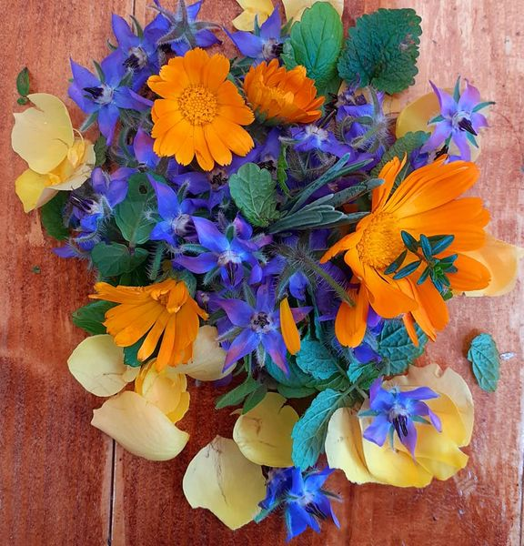
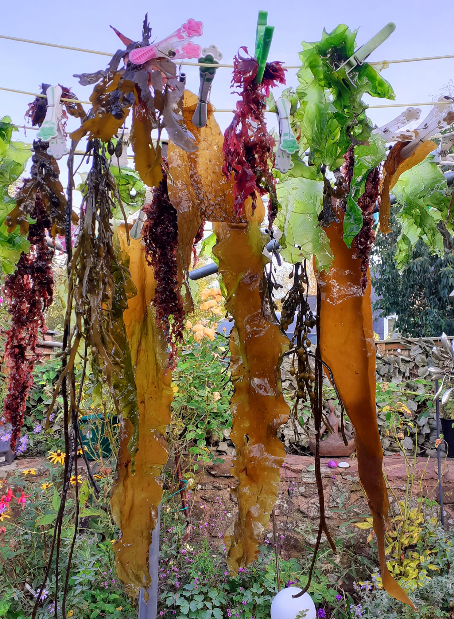

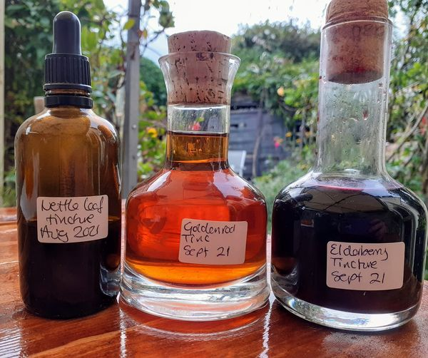

Beautiful photo credits: Christa Harris
Genuine grass-roots earth based herbalism - using native herbs
Simple practical local medicines for your own wellbeing and those around you
Harvesting and making your own remedies
Discover the healing properties of accessible plants, seaweeds and fungi
Practicing herbalists as tutors for the live online seminars
Online forums for discussion - create a herbal community
Recommended practical sessions in Devon, or in your locality
Herb walks
Meeting the plants
Developing your own relationship with herbs, including tea tasting
An encouragement to find out more, and/or as a stepping stone to further study
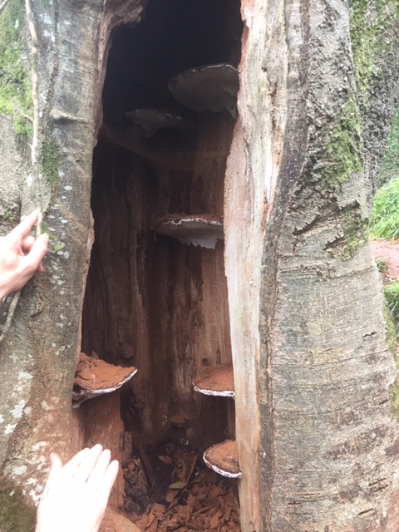
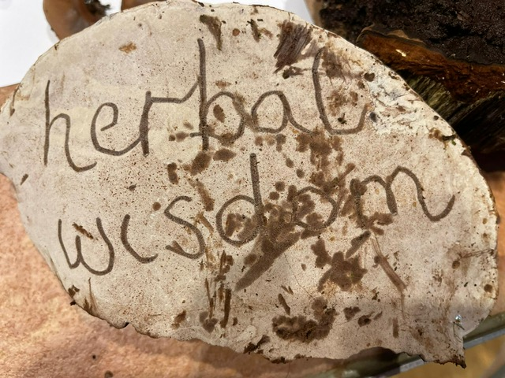

Medicinal fungus – ‘Artists bracket’ – Photo: Sara Hills

A systems approach | When  modules  start | Body focus | Herb examples included | Examples of learning activity, PRACTICALS
Building blocks – The Gut  Digestion, assimilation of nutrients from food. | September is course  introduction and first Practical | Digestive system and the gut bacteria. | Dandelion, Marshmallow Fennel  Peppermint  Agrimony | Bitters, gut soothing and restoring herbs. Making and tasting herb teas.
Protection  Strong defenses. | Sept./Oct./Nov. | Entry points for infection.  Immune system. | Elder, Echinacea, Elecampane, Turkey tail Thyme | 1st PRACTICAL DAY including fungi and seaweeds. Making infused oils.
Balance & equanimity  How herbal actions can help to relieve stress and anxiety. | November | Sleep, circadian rhythms and our primitive nervous system. | Chamomile, Lemon Balm  St Johns Wort  Skullcap | Discussion, reading and research. How a treatment plan could be used.
Herbal First aid  Simple acute medicine remedies. | January | Skin, muscles, bones and joints. | Calendula, Yarrow,  Comfrey and Teasel. | PRACTICAL DAY  Making an ointment. Skin remedies.
Purification  How the body filters fluids and keeps what it needs. | February | Bladder, kidneys sorting | Nettle, Birch leaf, cornsilk, couchgrass. | Herbs to help urinary health, flow and tract infections.
The Sorting House  Diet and nutrition. |  | Liver, gall bladder | Milk thistle and Artichoke. | Detoxing.  Food as medicine.
Communication within the body,  cognition herbs. | March | Main glands: adrenaline, metabolic ‘gears’ and blood sugar regulation. | Borage, Liquorice,  Holy basil and Rosemary | Appropriate medicine for the individual, communication skills.
Energy and exchange  Inner and outer environments: Breathing. | April | Lungs, and where oxygen goes. | Plantain  Cleavers, Burdock,  Red clover | PRACTICAL DAY – Actions of herbs, tonics and roots.
The matrix  What happens in our bodies at a microscopic level. |  | Lymph and  Interstitial fluid. | Bilberry and Ginkgo. | What are Anti-oxidants?
Sexual and reproductive herbs  Herbs to support pelvic circulation and hormone balance. | May | Female and male reproductive system herbs. | Sage, Hops, Raspberry leaf, Black cohosh and Mugwort. | Roles of key herbs in reproductive health.  Practical plant study of a wild herb.
A systems approach, continued | When  modules  start | Body focus | Herb examples included | Examples of learning activity, PRACTICALS
Heart herbs  Circulation, blood pressure, dynamics and return flow. | June | Cardiovascular system; heart and blood vessel health.  Herbs for the circulation | Hawthorn, Ginger, Horse chestnut. | PRACTICAL DAY – a healer may often see things that we can’t: finding each other’s key herbs.
“Stirring the Cauldron” – recap and refresh | July | Summary and overview.  Herb/drug interactions. | Midsummer herbs – Elderflower, Lime blossom and Rose | Revision.

The Course Tutors
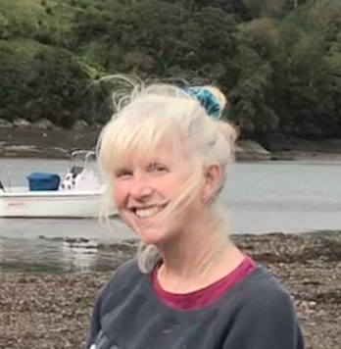 | 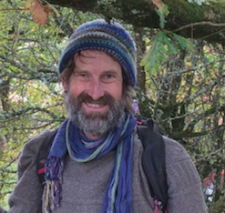
Sara Hills  I trained as a Medical Herbalist from the University of East London in 2007, and since then I have qualified in Sports Massage therapy. Now practicing from my clinic at Yealmbridge, near Plymouth. I teach and write modules for the School of Herbal Medicine, a professional course, and am a student clinic supervisor there. I lead seasonal forage walks in my locality; the South Hams estuary of Newton Ferrers, Devon. Previously working in agriculture and education, and now studying deeper into the nervous and endocrine systems I’ll always still be learning myself! I like to help people reconnect with the natural world and reclaim our herbal knowledge. | Peter Neumann  Qualifying professionally with the School of Phytotherapy in 2002, I practice from Totnes Natural Health Centre in Devon. For 21 years I have been part of Bowden House Community, which cares for 10 acres of grounds. Here I run volunteer afternoons, to grow herbs and make medicines.  Delighted too to be a Materia Medica (therapeutic herbs), course writer, teacher and a clinic supervisor at the School of Herbal Medicine in Somerset. Recently I have qualified in the UK, and the US, in “Plant Spirit Medicine”; I believe the plants hold a timeless wisdom in their relationship with us, and they wait for us to rekindle it.

Testimonials…..
Dear Sara and Peter

Firstly ~ thank you so much for this course which came along just at the right time for me after two years of pandemic stress and personal health challenges.
It gave me a lot of hope ~ learning new things and connecting deeper with nature and the nourishment that brings.
I appreciate the huge amount of work that has gone into planning the syllabus and creating seminar information.
I loved being at Bowden House in the gardens and the classroom ~ sharing lunch and the footbaths and tea drinking! Also loved the sea shore day with Sara!
Christa

Thank you so much for a great, in-depth course, which will take some time to digest. I echo what Christa and others shared today - that you obviously both worked very hard putting it all together!
I really enjoyed the hands-on practical days...which were all special in their own way but I particularly enjoyed the intro to seaweeds & fungi, as well as all the making of tinctures etc. They increased my knowledge and helped me gain confidence to start building up my own medicinal treasure chest and start sharing this with family and friends.

Also, the knowledge of the herbs has filtered into my everyday awareness more and more and I've noticed my interest in cooking increasing this past year...beyond doing my usual healthy meals, I've felt more adventurous to try out new recipes and of course include lots of yummy herbs and spices. Funny, I'd not made the connection before writing this feedback!
Camilla

I have very much enjoyed this course. The amount of information offered has been amazing. The practical days were lovely, calm, relaxing and hands-on which is the way I learn best. I have learnt such a lot and now feel confident to make teas and tinctures and suggest some basic herbal remedies for friends and family. I loved the enthusiasm you both brought to the course as a whole and this was very infectious. With love, thanks and best wishes, Penny

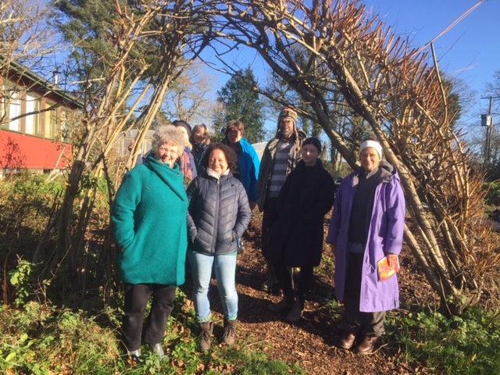
COURSE COSTS AND BOOKING  We are now taking bookings for the year Sept 2026 – July 2027 : Places are limited to 12 students, it is open to all with a keen interest in herbal medicine, who want to take their understanding further.  This course is also accessible to anyone who can’t attend the inperson practicals, and has access to a temperate climate like N. and W. Europe, the Eastern states of the US and Canada. It’s possible to complete the practicals in your area, with in-line support.  There are optional monthly assignments, which are marked and feedback given.  The cost of the whole course is £645 – this includes:  - 10 modules of 2 ½ hours of live webinar tuition on Zoom, with powerpoints, notes and a recording link.  - Tuition and materials on the 4 practical days – guided by the course tutors on 4 Sundays over the year.  - Tuition for a plant study in your locality.  - Course assessment and feedback  - The opportunity to connect with the other students  - The PRACTICAL DAYS will take place on weekends in October, December, late March and late May, and it's a great opportunity to learn herb identification and the hands on making of remedies together. Then you get to meet the tutors and connect with the other students.  - In addition to the tutorials, there is an optional “plant connection study” that you can do in your own locality in late May or June. | 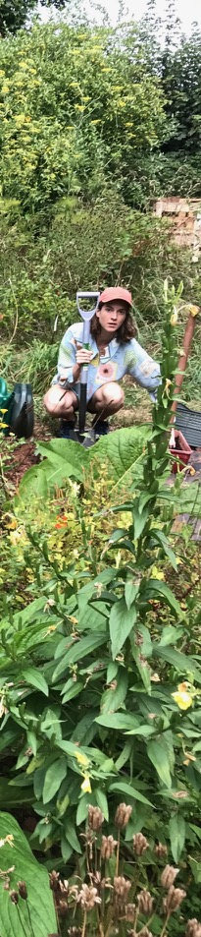 |  | COURSE COSTS AND BOOKING  We are now taking bookings for the September 21 – June 22 year: Places are limited to 12 students, it is open to all with a keen interest in herbal medicine, who want to take their understanding further.  This course is for those who have access to a temperate climate like N. and W. Europe, the Eastern states of the US and Canada, as we would like you to be able to visit wild herbs in your area.  There will be monthly assignments, parts of the course will be assessed, more details available on request  The basic cost of the whole course is £575 – this includes:  10 modules of 2 to 2 ½ hours of live webinar tuition on Zoom. Summary objectives and notes  Tuition on the 4 practical days – meeting the course tutors on 4 weekend days over the year  Tuition for a plant study in your locality  Course assessment and feedback  The opportunity to connect with the other students  The PRACTICAL DAYS will take place on weekends in October, December, late March and late May, and it's a great opportunity to learn herb identification and the hands on making of remedies together. And you get to meet us and the other students.
If you are from outside of the U.K., or are not able to travel, we can give you additional tuition to enable you to complete the practical day in your area. (Additional tuition is £40 for each session). If you have any learning needs that we can support you with please let us know. Flexible payment options are offered.  To book your place fill in the form sent as a separate document “COURSE COSTS AND BOOKING 2026.docx” and return it to sarajanehills@gmail.com. We are accredited with the Complementary Medicines Association.   |  |  |  | If you are from outside of the U.K., or are not able to travel, we can give you additional tuition 4 times to enable you to complete the practical days in your area, (Additional tuition is £80 for the years’ course).  There will be a plant study in your own locality in early June  If you have any learning needs that we can support you with please let us know  To book your place fill in the form below and return it to sarajanehills@gmail.com  If you need to contact us by phone text is preferred to Peter on +44 (0)7905 517972

